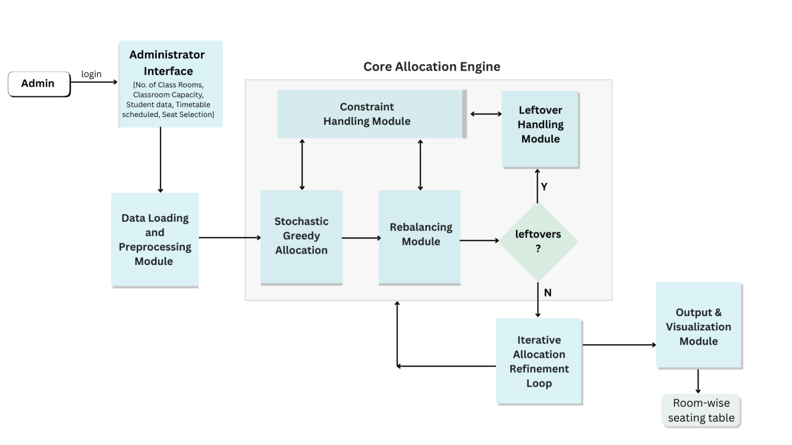

DATA LOADING AND PREPROCESSING MODULE (DLPM)
The Data Loading and Preprocessing Module (DLPM) constitutes the foundational stage of the examination seating allocation system. Its primary function is to ingest raw examination data, perform systematic cleaning and normalization, apply examination-type-specific transformations, and generate structured datasets suitable for automated allocation. The module is designed to support multiple examination categories, including Normal Examinations, Program Electives, and Open Electives, thereby ensuring adaptability and scalability across diverse academic scenarios.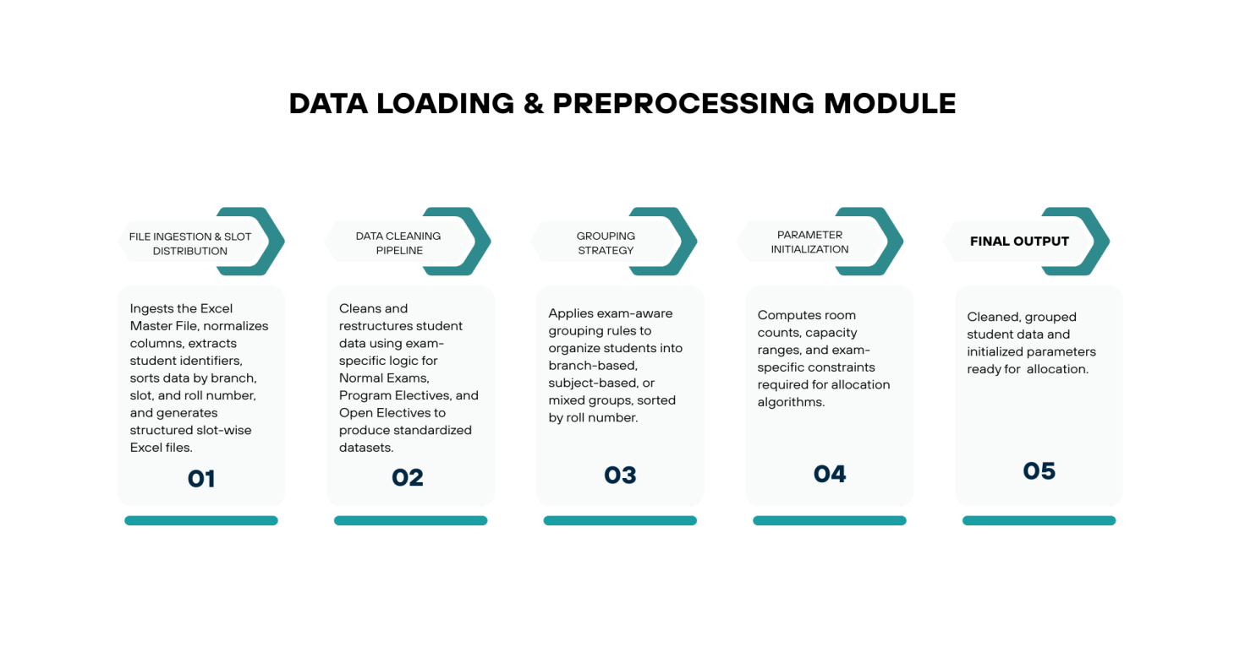

A. File Ingestion and Slot Distribution
The file ingestion process begins with loading a raw Excel Master File containing student examination records. Due to variations in data formatting and column nomenclature, a column detection and normalization mechanism is applied to standardize the input schema. Student identifiers are extracted using Name(Roll Number) pattern parsing, enabling accurate isolation of roll numbers from combined textual fields.
Following extraction, the records are hierarchically sorted based on branch, examination slot, and roll number to establish deterministic ordering. The sorted data is subsequently distributed into a hierarchical directory structure, where each examination slot is assigned a dedicated folder containing its corresponding Excel file. This organization facilitates independent slot-level processing and improves data traceability throughout the system pipeline.

B. Data Cleaning Pipeline
The Data Cleaning Pipeline is implemented as a configurable framework that dynamically adapts its processing logic according to the examination type. Its objective is to convert raw and inconsistent input data into standardized and validated datasets suitable for grouping and allocation.

1) Normal Examination Processing
For Normal Examinations, essential fields such as Register Number, Branch Name, and Course Information are extracted from the input dataset. Branch names are mapped to standardized branch codes using a predefined branch mapping table to ensure uniform representation across all system components.
Roll numbers are parsed using a key-based function that decomposes each identifier into admission year and serial number components. Based on this decomposition, students are classified as regular or supplementary candidates by comparing their admission year with the maximum admission year present within the corresponding branch. Supplementary data is aggregated at both branch and year levels to support downstream capacity planning and allocation constraints.
The output of this stage includes branch-wise master roll lists, class strength counts, and structured supplementary statistics.

2) Program Elective Processing
Program Elective processing focuses on subject-centric organization within specific academic programs. The pipeline extracts roll numbers, branch identifiers, and course titles from the dataset. Branch names are compressed into standardized short codes to reduce redundancy and improve consistency.
Course titles undergo normalization through the removal of extraneous annotations, such as parenthetical information, using regular expression-based cleaning techniques. A composite identifier in the form of branch:subject is generated to uniquely represent each elective offering. Records with missing or invalid attributes are filtered to preserve dataset integrity.
This stage produces a cleaned collection of tuples consisting of roll number, branch code, and subject name, which serves as the basis for elective grouping and analysis.

3) Open Elective Processing
Open Elective processing is designed to support cross-branch student participation. Student records are extracted across all branches and organized using a subject-centric approach. While subjects serve as the primary grouping dimension, branch metadata is retained to enable controlled mixing and statistical analysis of branch-wise participation.
The resulting dataset consists of subject-based groups augmented with branch-level enrollment information, supporting flexible yet constrained allocation strategies.

C. Grouping Strategy
The Grouping Strategy module converts cleaned datasets into structured, allocation-ready groupings. The grouping methodology varies according to the examination type to align with academic and administrative requirements.

1) Normal Examination Grouping
Normal Examinations employ strict branch-based grouping. For each branch, a master list of roll numbers is maintained and sorted based on parsed roll number keys to preserve chronological order. Branch-wise class strength and supplementary statistics are retained alongside roll lists to support balanced allocation decisions.

2) Program Elective Grouping
Program Electives utilize composite branch:subject identifiers to form subject-centric groups. Dynamic data structures are used to maintain student lists for each elective, with roll numbers sorted to ensure deterministic allocation. Enrollment counts are tracked independently to evaluate subject popularity and load distribution.

3) Open Elective Grouping
Open Electives adopt a subject-primary and branch-secondary grouping strategy. Students are first grouped by subject and then sub-grouped by branch. Sorting is applied hierarchically at the subject, branch, and roll number levels. Cross-tabulation statistics are generated to capture inter-branch enrollment patterns.

D. Parameter Initialization
Parameter Initialization computes the global and examination-specific parameters required for allocation algorithms. Common calculations include the total number of students, base room estimation derived from predefined capacity heuristics, and determination of permissible room ranges.
Examination-specific parameters incorporate branch distribution ratios and supplementary percentages for Normal Examinations, subject popularity and branch–subject matrices for Program Electives, and subject enrollment sizes with mixing constraints for Open Electives. System-level configurations define block-wise seating capacities, maximum room limits, and target balance thresholds to ensure compliance with institutional and infrastructural constraints.

E. Output of DLPM
The final output of the Data Loading and Preprocessing Module consists of fully cleaned, validated, and grouped student datasets integrated with initialized system parameters. This allocation-ready data is forwarded to the Classroom Allocation Module (CAM) for execution of examination seating and room allocation.

Constraint Handling Module (CHM)

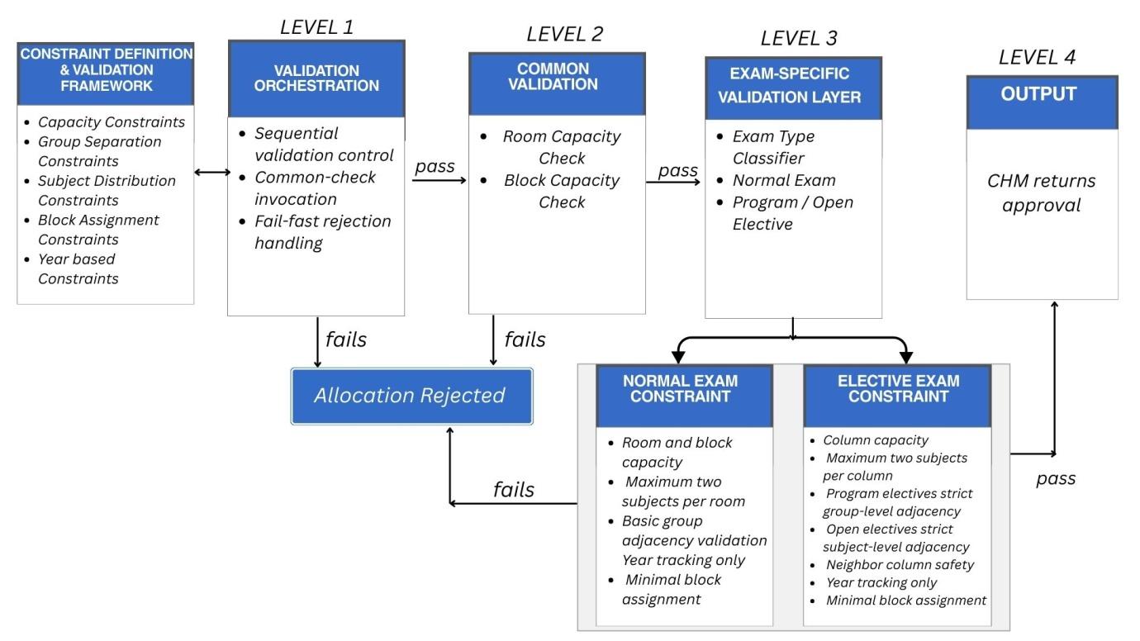

A. Role of the Constraint Handling Module
The Constraint Handling Module (CHM) serves as the rule-enforcement and validation backbone of the examination seating allocation system. While the Core Allocation Engine (CAM) is responsible for generating candidate seating arrangements, CHM verifies that each candidate complies with institutional, academic, and infrastructural constraints prior to finalization. By decoupling constraint validation from allocation generation, the system achieves improved modularity, maintainability, and a clear separation of concerns.
CHM operates as a deterministic validation module that evaluates tentative allocations and either approves them for commitment or rejects them for reallocation. This design guarantees constraint compliance independently of the specific allocation strategy employed by the Core Allocation Engine and enables consistent rule enforcement across different allocation strategies.

B. Constraint Definition Framework
At the core of CHM lies a centralized constraint definition framework that encapsulates all rules governing valid examination seating arrangements. These constraints are categorized into capacity constraints, group separation constraints, subject distribution constraints, block assignment constraints, and year-based constraints. Each category reflects examination regulations and physical infrastructure limitations, though some are implemented with varying enforcement levels.
Capacity constraints define upper bounds on the number of students permitted within a room and within individual seating blocks or columns and are fully enforced in the current implementation.
Group separation constraints regulate adjacency between academic groups. For elective examinations, strict adjacency-based validation is enforced to prevent academically incompatible placements. For normal examinations, group compatibility checks are present but permissive, allowing coexistence unless restricted by higher-level rules.
Subject distribution constraints regulate the number of subjects that may coexist within a room or column. The current implementation enforces a maximum of two subjects per room for normal examinations and a maximum of two subjects per column for elective examinations.
Block assignment constraints are architecturally supported but minimally enforced in the current version. The validation pipeline includes extensible hooks for subject-to-block mapping or column pairing logic, allowing future enforcement without altering the overall architecture.
Year-based constraints track regular and supplementary students during preprocessing for analytical visibility. However, they are not currently enforced as strict validation rules during allocation.
All constraints are defined independently of allocation logic, enabling reuse, extension, or modification without impacting the core allocation algorithms.

C. Constraint Validation Pipeline
Constraint validation within CHM is executed through a structured and sequential validation pipeline. This pipeline is invoked by the Core Allocation Engine each time a tentative allocation is generated. Validation is performed in a predefined order, beginning with capacity checks and progressing toward higher-level academic constraints.
Each validation stage produces a boolean outcome indicating success or failure. Upon encountering a failure, the pipeline immediately terminates and signals rejection to the allocation engine. This fail-fast behavior improves efficiency by eliminating infeasible candidates early and prevents partial validation states.
The validation pipeline is largely exam-type agnostic during its common stages and dynamically activates exam-specific validation logic based on examination metadata provided by the allocation engine.

D. Interaction with the Core Allocation Engine
The Core Allocation Engine (CAM) and CHM operate within a tightly coordinated yet logically separated feedback loop. CAM is responsible for proposing candidate allocations by selecting rooms, blocks or columns, subjects, and student groups according to optimization strategies such as load balancing or distribution balancing. However, CAM does not directly enforce constraints.
For each candidate allocation, CAM invokes CHM as a validation service, supplying the current room state, placement location, subject identifier, and associated student subset. CHM evaluates the candidate against all applicable constraints and returns either an approval or rejection decision.
Upon approval, CAM commits the allocation and updates the global seating state. Upon rejection, CAM discards the candidate and generates an alternative placement. This interaction model allows CAM to remain strategy-driven while delegating rule enforcement to CHM, resulting in a clean and extensible system architecture.

E. Exam-Type Adaptive Constraint Enforcement
CHM is designed to be exam-type adaptive, selectively applying different subsets of constraints based on the nature of the examination.
For Normal Examinations, CHM enforces room capacity limits, block capacity limits, and subject diversity limits within rooms. Group separation logic is present but permissive, allowing compatible coexistence across adjacent blocks. Year-based information is tracked for analytical purposes but not enforced as a hard constraint.
For Program Electives, CHM enforces column-wise capacity limits, maximum subject limits per column, and strict adjacency-based group separation. Neighboring column validation ensures that incompatible academic groups are not placed adjacently.
For Open Electives, CHM applies similar column capacity and subject distribution constraints but uses subject-level adjacency checks rather than group-level compatibility. This ensures that identical subjects are not placed in adjacent columns.
This adaptive behavior enables CHM to support heterogeneous examination formats within a unified validation framework while maintaining a shared validation pipeline.

F. Integration with Other System Modules
CHM receives its input indirectly from the Data Loading and Preprocessing Module (DLPM) through the Core Allocation Engine. DLPM supplies structured and grouped student datasets along with initialized system parameters such as room capacities and block definitions. These parameters are consumed by CHM during validation.
Downstream, CHM directly influences the final seating layout produced by CAM. Since only constraint-validated allocations are committed, CHM implicitly governs the correctness of the final output without directly performing allocation. This positioning establishes CHM as a gatekeeping module that ensures system-wide consistency and regulatory compliance.

G. Design Rationale and Benefits
The architectural separation of constraint handling from allocation logic offers several advantages. Centralized constraint enforcement simplifies correctness reasoning and ensures uniform policy application across allocation strategies. The modular design enables independent testing and verification of validation logic and allows future extensions to be incorporated with minimal architectural changes.
The presence of extensible validation hooks allows additional constraints—such as stricter block mappings or year-based enforcement—to be introduced without modifying the validation pipeline structure. By acting as a validation oracle for the Core Allocation Engine, the Constraint Handling Module ensures that the examination seating system remains modular, extensible, and robust under evolving institutional requirements.

Module 4: Rebalancing Module (RBM)

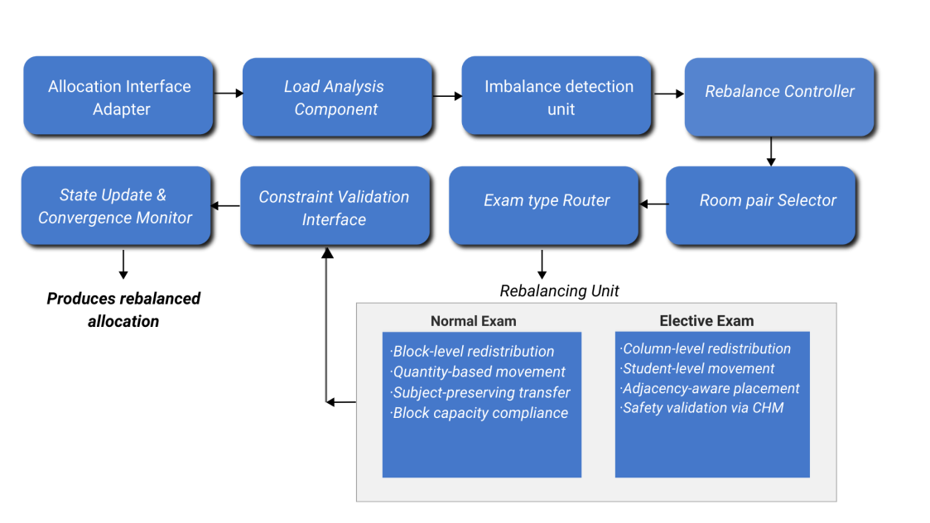
The Rebalancing Module (RBM) is a post-allocation optimization component responsible for correcting load imbalances across examination rooms after the initial seating allocation has been produced by the Core Allocation Engine (CAM). While the primary allocation phase focuses on constraint satisfaction and feasibility, RBM aims to improve allocation quality by achieving a more uniform distribution of students across available rooms without violating established constraints.
RBM operates exclusively on constraint-validated allocations and does not generate new seating arrangements from scratch. Instead, it performs controlled redistribution of students or student groups between rooms to reduce occupancy variance. This separation ensures that rebalancing remains a refinement stage rather than an alternative allocation mechanism.
Upon receiving the room-wise allocation state from CAM, RBM first computes the effective occupancy of each room. The computation strategy adapts to the examination type: for elective examinations, occupancy is derived from column-wise student counts, whereas for normal examinations, it is computed using block-level quantities. This adaptive load modeling allows RBM to operate uniformly across heterogeneous seating representations.
Following load computation, RBM identifies active rooms and determines the average occupancy across these rooms. Based on predefined tolerance thresholds, the module classifies rooms as overloaded or underloaded. The tolerance values are examination-type dependent, reflecting stricter balancing requirements for normal examinations and more flexible distribution for elective examinations.
Rebalancing is executed through an iterative control mechanism that selects source–target room pairs based on their degree of imbalance. In each iteration, RBM attempts to transfer a minimal unit of allocation from the most overloaded room to the most underloaded room. The transfer granularity and movement logic depend on the examination type: student-level transfers are performed for elective examinations, while quantity-based block transfers are applied for normal examinations to preserve subject grouping.
All redistribution attempts are validated against existing constraints through interaction with the Constraint Handling Module (CHM). For elective examinations, adjacency-based safety checks are enforced to prevent incompatible subject placement. For normal examinations, block capacity and subject consistency constraints are preserved during movement. If a valid transfer cannot be identified, the rebalancing process terminates gracefully.
The rebalancing loop continues until either the room loads converge within the defined tolerance range or no further valid transfers are possible. At completion, RBM returns a rebalanced allocation to CAM for final commitment.
By functioning as a post-processing refinement layer, RBM enhances overall seating efficiency while preserving the correctness guarantees enforced during initial allocation. Its modular integration with CAM and CHM ensures scalability, maintainability, and adaptability to diverse examination formats.

Leftover Handling Module (LHM)
The Leftover Handling Module (LHM) is a specialized post-allocation component designed to ensure complete placement of all remaining unassigned students after the primary allocation and rebalancing phases. Its role is to guarantee allocation completeness while preserving system-wide constraints and room integrity. LHM operates differently depending on the examination type, reflecting the inherent structural differences between program elective and normal examination seating models.
For program elective examinations, leftover handling is intrinsically embedded within the Core Allocation Module (CAM). The multi-pass column-filling strategy employed by CAM progressively relaxes placement density constraints, ensuring that residual students are absorbed during later passes. As a result, no standalone leftover handling phase is required for elective examinations, and LHM remains logically inactive in this mode.
In contrast, normal examinations require an explicit leftover resolution mechanism due to strict block-based seating rules, subject separation requirements, and hard room capacity limits. In this context, LHM is activated as a dedicated final-stage module.
Upon invocation, LHM receives the partially filled room allocation, along with a list of leftover students represented by their corresponding branch or subject identifiers. The module begins by aggregating these leftovers into branch-wise counts, allowing batch-based placement rather than individual student handling. This aggregation improves both efficiency and placement consistency.
LHM follows a load-aware distribution strategy by prioritizing rooms with lower current occupancy. Rooms are dynamically ordered based on their total assigned strength, ensuring that additional students are directed toward underutilized spaces first. Fully occupied rooms are explicitly excluded from consideration to prevent capacity violations.
For each branch, LHM attempts placement using a two-tiered strategy. First, it checks whether the branch already exists within a room. If so, additional students are appended to the corresponding block, provided that block-level capacity constraints are not exceeded. This approach minimizes subject fragmentation and preserves block homogeneity.
If the branch does not already exist in the room, LHM evaluates whether the room can accommodate an additional subject. Subject introduction is permitted only if the maximum subject limit per room is not violated. When eligible, the module assigns the leftover students to an available empty block, respecting both block capacity and overall room capacity constraints.
Throughout the placement process, LHM enforces all constraints previously validated by the Constraint Handling Module (CHM), including room capacity, block capacity, and subject count restrictions. No redistribution or reassignment of previously placed students is performed, ensuring that LHM operates strictly as a completion mechanism rather than a corrective one.
Once all leftovers are either placed or no further valid placements are possible, LHM returns the updated room allocation to the core system. By isolating leftover resolution into a dedicated module, the system achieves a clear separation of concerns, improved robustness, and guaranteed allocation completeness for normal examinations.

